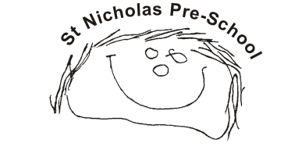
St. Nicholas Pre-School COVID Outbreak & Infection Control Contingency Plan – Updated September 2021
- Ensure all official documentation is followed, namely: ‘Guidance for Childcare and Educational Settings in the Management of COVID-19’ (most recent update); ‘Contingency framework: education and childcare settings (August 2021)’ and ‘Checklist for Acute respiratory Infection management in Education Settings’. Copies are enclosed as related documents.
- All children in the setting are under 18 and all staff are fully vaccinated so in accordance with current guidelines no-one in the setting should have to isolate if notified as close contact, although a PCR test is advised.
- All staff to complete twice weekly Lateral Flow tests.
- If any staff have a positive PCR test and cannot attend setting, Managers are to arrange cover so that EYFS ratios are fulfilled and we always have a First Aider in each session.
- If numbers of staff out of setting due to positive PCRs mean that we cannot fulfil ratios/first aid requirements, the setting is to shut until staffing levels are back to required levels. If setting is shut we will continue to support our children by providing at-home activities and keep constant contact, where necessary, for safeguarding purposes.
- Daily cleaning agenda to continue – schedule is displayed and actioned.
- Children continue with staggered arrival/departure times, with parents waiting outside setting, on suggested 2 metre spaced spots.
- Information given to parents about our infection control procedures (see document).
- When large members of parents in setting (stay & play, maximum 20 parents), advise to wear masks. Limit times when parents are let in setting and limit numbers of parents.
- Ensure good ventilation throughout setting – doors & windows open; play outside as much as possible.
- If a child shows COVID symptoms whilst in the setting, one member of staff (who will wear appropriate PPE) is to stay with the child in a separate area of the setting to others, until a carer arrives for collection.
- Inform parents that no child with COVID symptoms should be coming into the setting and that a PCR test should be arranged.

