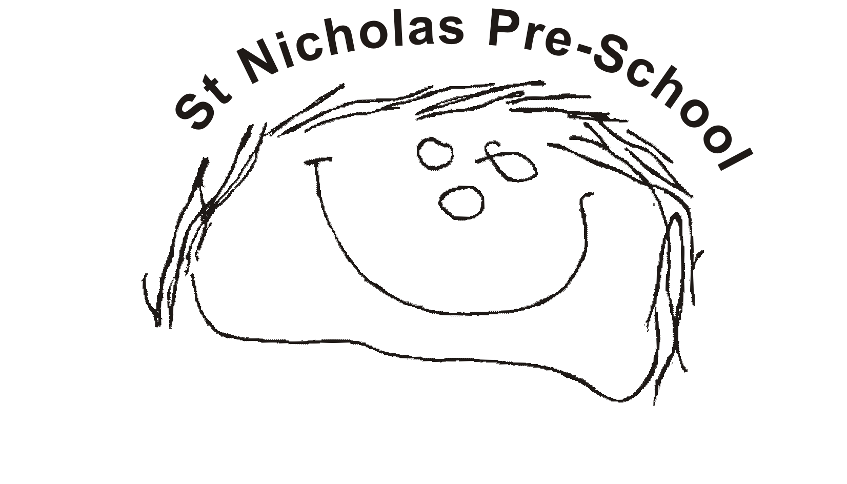
07 Record keeping procedures
07.4 Transfer of records
Records about a child’s development and learning in the EYFS are made by the setting; to enable smooth transitions, appropriate information is shared with the receiving setting or school at transfer. Confidential records are passed on securely where there have been concerns, as appropriate.
Transfer of development records for a child moving to another early years setting or school
- It is the designated person’s responsibility to ensure that records are transferred and closed in accordance with the archiving procedures, set out below.
- If the Local Safeguarding Partners (LSP) retention requirements are different to the setting, the designated person will liaise with their line manager, and seek legal advice if necessary.
Development and learning records
- The key person prepares a summary of achievements in the prime and specific areas of learning and development
- This record refers to any additional languages spoken by the child and their progress in all languages.
- The record also refers to any additional needs that have been identified or addressed by the setting and any action plans.
- The record also refers to any special needs or disability and whether early help referrals, or child in need referrals or child protection referrals, were raised in respect of special educational needs or disability, whether there is an Action Plan (or other relevant plan, such as CIN or CP, or early help) and gives the name of the lead professional.
- The summary shared with schools should also include whether the child is in receipt of, or eligible for EYPP or other additional funding.
- The record contains a summary by the key person and a summary of the parents’ view of the child.
- The document may be accompanied by other evidence such as photos or drawings that the child has made.
- The setting will use the local authority’s assessment summary format or transition record, where these where provided.
- Whichever format of assessment summary is used, it should be completed and shared with the parent prior to transfer.
Transfer of confidential safeguarding and child protection information
- The receiving school/setting will need a record of child protection concerns raised in the setting and what was done about them. The responsibility for transfer of records lies with the originating setting, not on the receiving setting/school to make contact and request them.
- To safeguard children effectively, the receiving setting must be made aware of any current child protection concerns, preferably by telephone, prior to the transfer of written records.
- Parents should be reminded that sensitive information about their child is passed onto receiving settings where there have been safeguarding concerns and should be asked to agree to this prior to the information being shared. Settings are obliged to share data linked to “child abuse” which is defined as physical injury (non-accidental) physical and emotional neglect, ill treatment and abuse.
- Parents/carers should be asked to agree to this, however, where safeguarding concerns have reached the level of a referral being made to local children’s social work services (either due to concerns that a child may be at risk of significant harm or that a child may be in need under Section 17 of the Children Act,) if consent is withheld the information will most likely need to be shared anyway. It is important that any decisions made to share or not share with or without consent are fully recorded.
- For any safeguarding or welfare concerns that resulted in an early help referral being made, and if consent to share is withheld, legal advice is sought prior to sharing.
- If the level of a safeguarding concern has not been such that a referral was made for early help, or to children’s social work services or police, the likelihood is that any concerns were at a very low level and if they did not meet the threshold for early help, they are unlikely to need to be shared as child abuse data with a receiving setting, however, the designated person should make decisions on a case by case basis, seeking legal advice is necessary.
- The designated person should check the quality of information to be transferred prior to transfer, ensuring that any information to be shared is accurate, relevant, balanced and proportionate. Parents can request that any factual inaccuracies are amended prior to transfer.
- If a parent wants to see the exact content of the safeguarding information to be transferred, they should go through the subject access request process. It is important that a child or other person is not put at risk through information being shared.
- If no referrals have been made for early help or to children’s social work services and police, there should not normally be any significant information which is unknown to a parent being shared with the receiving school or setting.
- If a parent has objections or reservations about safeguarding information being transferred to the new setting, or if it is unclear what information should be included, the designated person will seek legal advice.
- In the event that LSP requirements are different to the setting’s this must be explained to the parent, and recorded on form 6.4d, and a record of the discussion should be signed by parents to indicate that they understand how the information will be shared, in what circumstances, and who by.
- Prior to sharing the information with the receiving setting the designated person should check LSP retention procedures and if it becomes apparent that the LSP procedures are materially different to setting’s procedures this is brought to the attention of the designated person’s line manager, who will agree how to proceed.
- If a child protection plan or child in need plan is in place a Child welfare and protection summary is also photocopied and a copy is given to the receiving setting or school, along with the date of the last professional meeting or case conference.
- If a S47 investigation has been undertaken by the local authority a copy of the child welfare and protection concern summary form is given to the receiving setting/school.
- Where a CAF/early help assessment has been raised in respect of welfare concerns, the name and contact details of the lead professional are passed on to the receiving setting or school.
- If the setting has a copy of a current plan in place due to early help services being accessed, a copy of this should be given to the receiving setting, with parental consent.
- Where there has been a S47 investigation regarding a child protection concern, the name and contact details of the child’s social worker will be passed on to the receiving setting/school, regardless of the outcome of the investigation.
- Where a child has been previously or is currently subject to a child protection plan, or a child in need plan, the name and contact details of the child’s social worker will be passed onto the receiving setting/school, along with the dates that the relevant plan was in place for.
- This information is posted (by ‘signed for’ delivery) or taken to the school/setting, addressed to the setting’s or school’s designated person for child protection and marked confidential. Electronic records must only be transferred by a secure electronic transfer mechanism, or after the information has been encrypted.
- Parent/carers should be made aware what information will be passed onto another setting via 07.1a Privacy notice.
- Copies of the last relevant initial child protection conference/review, as well as the last core group or child in need minutes can be given to the setting/school.
- The setting manager must review and update a Child welfare and protection summary, checking for accuracy, proportionality, and relevance, before this is copied and sent to the setting/school.
- The setting manager ensures the remaining file is archived in line with the procedures set out below.
No other documentation from the child’s personal file is passed to the receiving setting or school. The setting keeps a copy of any safeguarding records in line with required retention periods.
Archiving children’s files
- Paper documents are removed from the child’s file, taken out of plastic pockets and placed in a robust envelope, with the child’s name and date of birth on the front and the date they left.
- The designated person writes clearly on the front of the envelope the length of time the file should be kept before destruction.
This is sealed and placed in an archive box and stored in a safe place i.e. a locked cabinet for three years or until the next Ofsted inspection conducted after the child has left the setting, and can then be destroyed.
- For web-based or electronic children’s files, the designated person must also use the archiving procedure, and records details of what needs to be retained/destroyed. The designated person must make arrangements to ensure that electronic files are deleted/retained as required in accordance with the required retention periods in the same way as paper based files.
- Health and safety records and some accident records pertaining to a child are stored in line with required retention periods.

