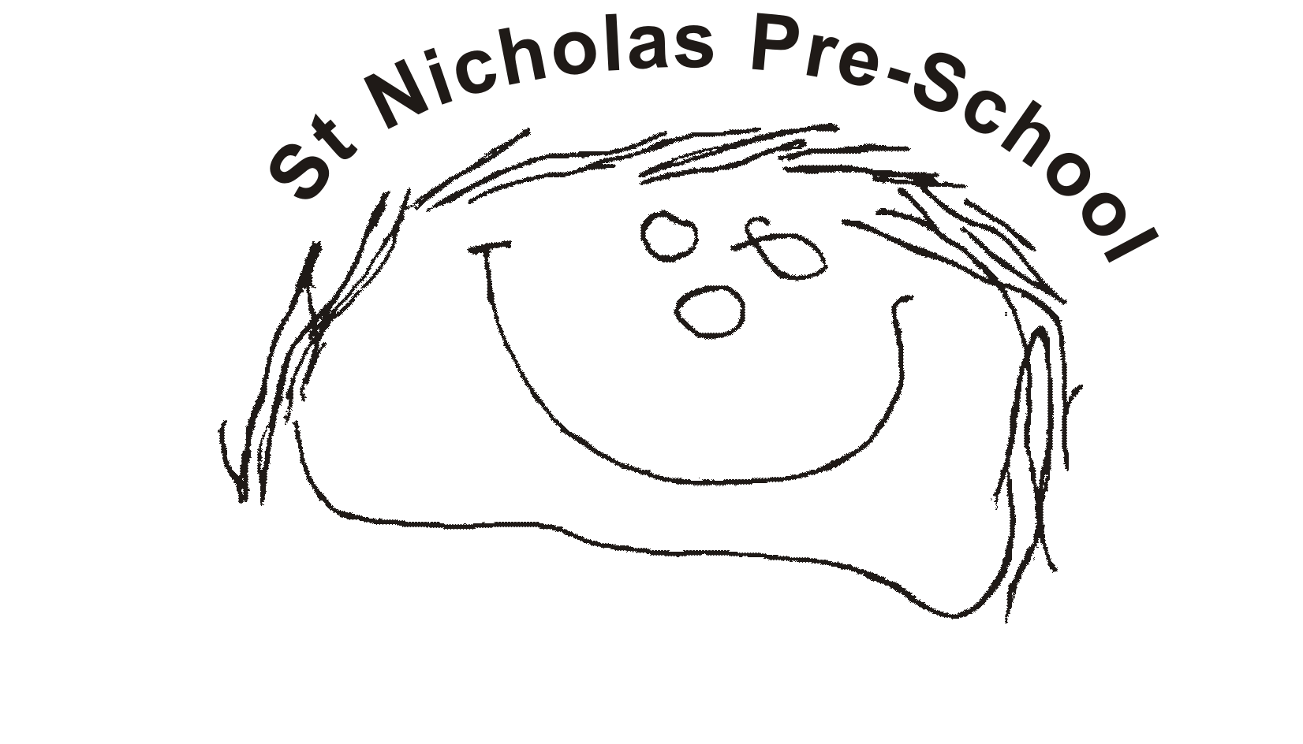
06 Safeguarding children, young people and vulnerable adults procedures
06.8 Looked after children
Identification.
A 'Looked after Child' is a child in public care, who is placed with foster carers, in a residential home or with parents or other relatives.
Services provided to Looked After Children
Three- and four-year-olds
- Places will be offered for funded three- and four-year -olds who are looked after; where the placement in the setting will normally last a minimum of six weeks.
- If a child who attends a setting is taken into care and is cared for by a local carer the place will continue to be made available to the child.
Additional Support
- The designated person and key person liaise with agencies and professionals involved with the child, and his or her family, and ensure appropriate information is gained and shared.
- A meeting of professionals involved with the child is convened by the setting at the start of a placement. A Personal Education Plan (PEP) for children over 3 years old is put in place within 10 days of the child becoming looked after.
- Following this meeting, a Care plan for looked after children form is completed. The care plan is reviewed after two weeks, six weeks, three months, and thereafter at three to six monthly intervals.
- Regular contact will be maintained with the social worker through planned meetings, which will include contribution to the PEP which is reviewed annually.

