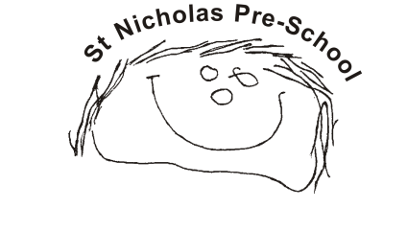
04. Health procedures
04.6 Oral health
The setting provides care for children and promotes health through promoting oral health and hygiene, encouraging healthy eating, healthy snacks and tooth brushing.
- Fresh drinking water is available at all times and easily accessible.
- Sugary drinks are not served by the setting.
- Parents are discouraged from sending in confectionary as a snack or treat.
Pacifiers/dummies
- Parents are advised to stop using dummies/pacifiers once their child is 12 months old.
- Dummies are not used at Pre-school.
Further guidance
Infant & Toddler Forum: Ten Steps for Healthy Toddlers www.infantandtoddlerforum.org/toddlers-to-preschool/healthy-eating/ten-steps-for-healthy-toddlers/

