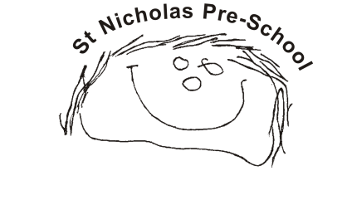
04 Health procedures
04.05b Infection control
Good practice infection control is paramount in early years settings. Young children’s immune systems are still developing, and they are therefore more susceptible to illness.
Prevention
- Minimise contact with individuals who are unwell by ensuring that those who have symptoms of an infectious illness do not attend settings and stay at home for the recommended exclusion time (see below UKHSA link).
- Always clean hands thoroughly, and more often than usual where there is an infection outbreak.
- Ensure good respiratory hygiene amongst children and staff by promoting ‘catch it, bin it, kill it’ approach.
- Where necessary, for instance, where there is an infection outbreak, wear appropriate PPE.
Response to an infection outbreak
- Manage confirmed cases of a contagious illness by following the guidance from the UK Health Security Agency (UKHSA)
Informing others
Early years providers have a duty to inform Ofsted where this is a confirmed case of a Notifiable Disease in their setting. Coronavirus is now classed as a ‘Notifiable Disease’.
Please note that it is not the responsibility of the setting to confirm a notifiable disease. This can only be done by a clinician (GP or Doctor). If a child is displaying symptoms that indicate they may be suffering from a notifiable disease parents must be advised to seek a medical diagnosis, which will then be ‘notified’ to the relevant body. Once a diagnosis is confirmed, it is the provider’s duty to notify Ofsted and to take advice from the UKHSA.
Further guidance
Good Practice in Early Years Infection Control (Alliance 2009)

