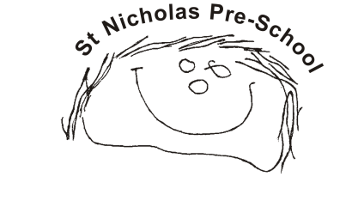
04 Health procedures
4.5(a) Managing a suspected case of Coronavirus
The main symptoms of coronavirus are:
- a high temperature
- a new continuous cough – this means coughing a lot, for more than an hour, or three or more coughing episodes in 24 hours
- a loss of change to smell or taste – this means they cannot smell or taste anything, or things smell or taste different to normal
Please refer to the latest government guidance on next-steps-for-living-with-COVID. If it is suspected that a child has COVID, staff do not attempt to diagnose or make assumptions about symptoms presented. They should immediately respond and take action as detailed in this procedure. This includes asking parents/carers to seek further advice from a medical practitioner who may/or may not advise that the symptoms meet the criteria for testing. In which case if the child appears well and displays no further suspect symptoms, they can return to the setting within the timescale advised by the medical practitioner.
The focus on coronavirus must not detract from staff being alert to the signs and symptoms linked to other serious illness as detailed below:

What to do if a child seems very unwell

Children and babies will still get illnesses that can make them very unwell quickly. It is important to get seek medical help and to contact the child’s parents immediately.

Call 999 if a child:
- has a stiff neck
- has a rash that does not fade when you press a glass against it
- is bothered by light
- has a seizure or fit for the first time
- has unusually cold hands
- has pale, blotchy, blue or grey skin
- has a weak, high-pitched cry that is not like their usual cry
- is extremely agitated (does not stop crying) or is confused
- finds it hard to breathe
- has a soft spot on their head that curves outwards
- is not responding like they normally do
Being prepared
- All staff are aware of this procedure and their responsibility if a child becomes unwell with coronavirus symptoms at the setting.
- Staff are instructed in how to remove and dispose of PPE equipment safely – this includes aprons and gloves worn during routine care procedures. We display the NHS guide to putting on and removing PPE.
If a child becomes unwell
- If a child is displaying any of the symptoms of coronavirus. The manager/deputy calls their parents to collect them immediately. Current guidance states that: ‘If a child or young person has a positive COVID-19 test result they should try to stay at home and where possible avoid contact with other people for 3 days after the day they took the test. The risk of passing the infection on to others is much lower after 3 days, if they feel well and do not have a high temperature. Children and young people who usually attend an education or childcare setting and who live with someone who has a positive COVID-19 test result should continue to attend as normal’.
- We will maintain contact with the parent(s) of the child who was sent home, and ensure they know that their child is entitled to a test and encourage them to get their child tested. To access testing parents should use the 111 online coronavirus service.
- We will ask the parent(s) to let us know the outcome as soon as possible.
- If the test result is positive we will inform all other parents that a child has tested positive and remind them to be aware of the symptoms to look out for.
- We will inform our local authority if a child, or staff member in the setting tests positive for coronavirus.
- We will also inform Ofsted as coronavirus is now classified as a Notifiable Disease.

