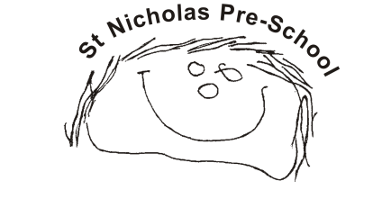
04 Health procedures
04.3 Life-saving medication and invasive treatments
Life-saving medication and invasive treatments may include adrenaline injections (Epipens) for anaphylactic shock reactions (caused by allergies to nuts, eggs etc) or invasive treatment such as rectal administration of Diazepam (for epilepsy).
- The key person responsible for the intimate care of children who require life-saving medication or invasive treatment will undertake their duties in a professional manner having due regard to the procedures listed above.
- The child’s welfare is paramount, and their experience of intimate and personal care should be positive. Every child is treated as an individual and care is given gently and sensitively; no child should be attended to in a way that causes distress or pain.
- The key person works in close partnership with parents/carers and other professionals to share information and provide continuity of care.
- Children with complex and/or long-term health conditions have a health care plan (04.2a) in place which takes into account the principles and best practice guidance given here.
- Key persons have appropriate training for administration of treatment and are aware of infection control best practice, for example, using personal protective equipment (PPE).
- Key persons speak directly to the child, explaining what they are doing as appropriate to the child’s age and level of comprehension.
- Children’s right to privacy and modesty is respected. Another practitioner is usually present during the process.
Record keeping
For a child who requires invasive treatment the following must be in place from the outset:
- a letter from the child's GP/consultant stating the child's condition and what medication if any is to be administered
- written consent from parents allowing members of staff to administer medication
- proof of training in the administration of such medication by the child's GP, a district nurse, children’s nurse specialist or a community paediatric nurse
- a healthcare plan
- Copies of all letters relating to these children must be sent to the insurance provider for appraisal. Confirmation will then be issued in writing confirming that the insurance has been extended. A record is made in the medication record book of the intimate/invasive treatment each time it is given.
Physiotherapy
- Children who require physiotherapy whilst attending the setting should have this carried out by a trained physiotherapist.
- If it is agreed in the health care plan that the key person should undertake part of the physiotherapy regime then the required technique must be demonstrated by the physiotherapist personally; written guidance must also be given and reviewed regularly. The physiotherapist should observe the practitioner applying the technique in the first instance.
Safeguarding/child protection
- Practitioners recognise that children with SEND are particularly vulnerable to all types of abuse, therefore the safeguarding procedures are followed rigorously.
- If a practitioner has any concerns about physical changes noted during a procedure, for example unexplained marks or bruising then the concerns are discussed with the designated person for safeguarding and the relevant procedure is followed.
Treatments such as inhalers or Epi-pens must be immediately accessible in an emergency.

