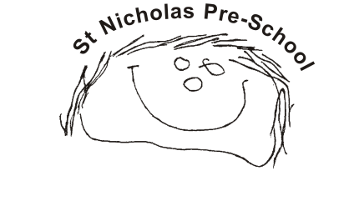
03 Food safety and nutrition procedures
03.1 Food preparation, storage and purchase

Purchasing and storing food
- Food is purchased from reputable suppliers.
- Pre-packed food (any food or ingredient that is made by one business and sold by another such as a retailer or caterer) is checked for allergen.
- Parents are requested not to bring food that contains nuts. Staff check packets to make sure they do not contain nuts or nut products.
- Bulk buy is avoided where food may go out of date before use.
- All opened dried food stuffs are stored in airtight containers.
- Dried packaged food is not decanted from packaging into large bins or containers as this prevents monitoring of sell by/use by dates and allergen information.
- Food is regularly checked for sell by/use by dates and any expired items are discarded.
- Items are not stored on the floor; floors are kept clear so they can be easily swept.
- Perishable foods such as dairy produce, meat and fish are to be used the next/same day. Soft fruit and easily perishable vegetables are kept in the fridge at 1- 5 Celsius.
- Packaged frozen food should be used by use by dates.
- Fridge and freezer thermometers should be in place. Recommended temperatures for fridge 37 degrees Fahrenheit (3 degrees Celsius), and freezers 0 degrees Fahrenheit (-18 degrees Celsius). Temperatures must be checked and recorded daily to ensure correct temperatures are being maintained.
- Freezers are defrosted every 3 months or according to the manufacturer’s instructions.
- Staff’s own food or drink should be kept in separate designated area of the fridge; where possible, a fridge should be kept in the staff room to avoid mix ups.
- Items in fridges must be regularly checked to ensure they are not past use by dates.
Preparation of food
- Food handlers must check the content of food/packets to ensure they do not contain allergens.
- Food handlers wash hands and cover any cuts or abrasions before handling food.
- All vegetables and fruit are washed before preparing.

Serving Food
- Tables are cleaned before and after, with soapy water or a suitable non-bleach product.
- Members of staff serving food wash their hands and cover any cuts with a blue plaster.
E.coli prevention
Staff who are preparing and handling food, especially food that is not pre-prepared for consumption e.g. fruit and vegetables grown on the premises, must be aware of the potential spread of E.coli and must clean and store food in accordance with the E.coli 0157 guidance, available at:
www.food.gov.uk/business-industry/guidancenotes/hygguid/ecoliguide#.U7FCVGlOWdI
Further guidance
Eat Better, Start Better (Action for Children 207) www.foundationyears.org.uk/eat-better-start-better/
Example Menus for Early Years Settings in England (PHE 2017) www.gov.uk/government/publications/example-menus-for-early-years-settings-in-england
Safe Food Better Business www.food.gov.uk/business-guidance/safer-food-better-business-sfbb
Allergen information for loose foods (Food Standards Agency 2017) www.food.gov.uk/sites/default/files/media/document/loosefoodsleaflet.pdf
Campylobacter (Food Standards Agency) www.food.gov.uk/news-updates/campaigns/campylobacter/fsw-2014

