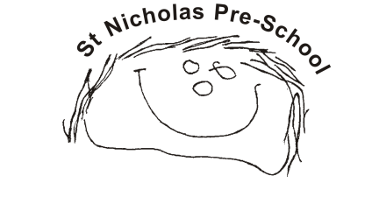
01 Health and safety procedures
01.12 Manual handling
- All staff comply with risk assessment and have a personal responsibility to ensure they do not lift objects likely to cause injury. Failure to do so may invalidate an insurance claim.
- Members of staff bring the setting manager’s attention to any new risk, or situations where the control measures are not working.
- Risk assessments may need to be changed for some individuals, such as a pregnant woman, or staff with an existing or previous injury or impairment that may affect their capacity to lift.
- Risk assessment is carried out of the environment in which the lifting is done. Features such as uneven floor surfaces, stairs, etc. add to the general risk and need to be taken into consideration.
- The setting managers ensure that they and their staff are trained to lift and move heavy objects and unstable loads correctly. Babies and young children are also heavy and need to be lifted and carried carefully and correctly.
Guidelines:
- Do not lift heavy objects alone. Seek help from a colleague.
- Bend from the knees rather than the back.
- Do not lift very heavy objects. even with others. that are beyond your strength.
- Use trolleys for heavy items that must be carried or moved on a regular basis.
- Items should not be lifted onto, or from, storage areas above head height.
- Do not stand on objects, other than proper height steps, to reach high objects and never try to over-reach.
- Push rather than pull heavy objects.
- Do not carry heavy objects up or down stairs; or carry large objects that may block your view of the stairs.
- Do not hold babies by standing and resting them on your hips.
Please note this is not an exhaustive list.
- Managers are responsible for carrying out risk assessment for manual handling operations, which includes lifting/carrying children and lifting/carrying furniture or equipment.

