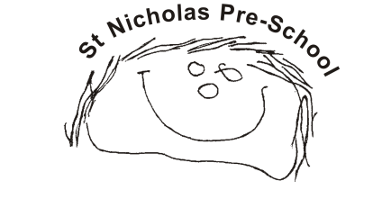
01 Health and safety procedures
01.10 Entrances and approach to the building
- Entrances and approaches are kept tidy and always uncluttered.
- All gates and external fences are childproof and safe
- Front doors are always kept locked and shut.
- Where possible, entry phones and ‘spy holes’ are used in the main door at a suitable height
- The identity of a person not known to members of staff is checked before they enter the building.
- All staff and visitors to the setting sign in and out of the building.
- A member of staff is available to open and close the door and to greet arrivals, say goodbye to parents and to make sure that doors and gates are shut.
- Back doors are always kept locked and shut if they may lead to a public or unsupervised area, unless this breaches fire safety regulations or other expectations.
- Where building works or repairs mean that normal entrances/exits or approaches to the building are not in use, a risk assessment is conducted to maintain safety and security whilst the changes are in place.
- Whilst social distancing restrictions are in place a risk assessment identifies measures required to keep parents two metres apart and to reduce risk of parents gathering in entrance areas during peak times.

