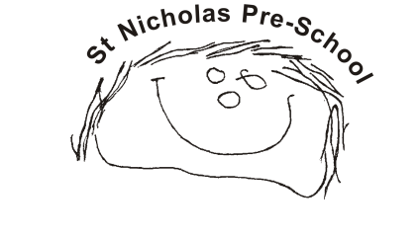
0.1 Health and safety procedures
01.2 Group rooms, stair ways and corridors
- Significant changes such as structural alterations or extensions are reported to Ofsted. A risk assessment is done to ensure the security of the building during building work.
- Door handles are placed high or alternative safety measures are in place.
- Chairs are stacked safely and not too high.
- There are no trailing wires; all radiators are guarded.
- Windows are opened regularly to ensure flow of air.
- Floors are properly dried after mopping up spills.
- Children do not have unsupervised access to stairways and corridors.
- Staff hold the hand of toddlers and children who require assistance.
- Materials and equipment are not generally stored in corridors, but where this is the case, it does not block clear access or way out.
- Walkways and stairs are uncluttered and adequately lit.
- Corridors are checked to ensure that safety and security is maintained, especially in areas that are not often used, or where there is access to outdoors
- Socket safety inserts are not used as there is no safety reason to do so, modern plug sockets are designed to remove risk of electrocution if something is poked into them. Socket covers (that cover the whole socket and switch) may be used, please note these are different to socket inserts.
- The use of blinds with cords is avoided. Any blinds fitted with cords are always secured by cleats. There are no dangling cords.

